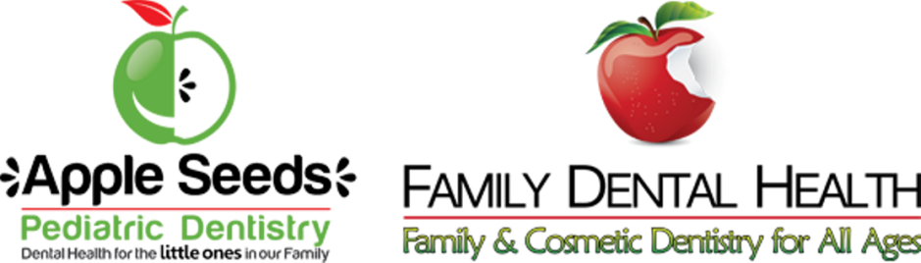

CONSENT FOR TREATMENT

1. I request and authorize the dental treatment by the doctors and staff of Apple Seeds Pediatric Dentistry for (Patient Name) _

2. I am the legal guardian of the child named above. (Initials)

3. I further request and authorize an examination, taking X-rays, cleaning teeth, giving
fluoride treatment, and providing oral hygiene instructions if deemed necessary.

4. I also give permission to provide my child with emergency care if needed.

5. Following a consultation, authorization is hereby granted to provide my child’s dental treatment which may include, but is not limited to radiographic, restorative, local anesthetic, nitrous oxide, oral surgical, behavior management, and protective stabilization techniques which are reasonable, necessary, and advisable for the treatment of children.

6. The risks, benefits, and alternatives of all treatment and techniques have been discussed with me and all of my questions have been answered. If, during treatment, unforeseen conditions are revealed which necessitate an extension of the original procedure or a different procedure than planned, I authorize such procedures as are necessary and desirable in the exercise of the dentist’s professional judgment. I understand that dental medicine/surgery is not an exact science and a precise outcome or perfect result is not guaranteed.

7. I authorize my pediatrician or other physician(s)/medical facilities to release any and all
pertinent medical information regarding my child.

8. I further understand that this consent will remain in effect until such time that I choose to
terminate it.

9. I understand that I accept responsibility for payment of services rendered.

10. I certify the truth of the information given. I also authorize the release of pertinent
information to those persons requiring it for treatment of my child or for the purpose of
payment of the account or credit references.

Signed: ____________________________________ Date: ______________

